Chapter No 7
TYPES OF COMPUTER

The computer sitting on the desk in your classroom is a microcomputer. It is a small, powerful piece of equipment. Even so, the power of the microcomputer is not enough for most large organizations. The computer industry consists of more than just microcomputers.
Any classification of computers is somewhat arbitrary. Computer can be classified it to following basis defined below.
- On the basis of functionality
- On the basis of Size, Speed and Cost.
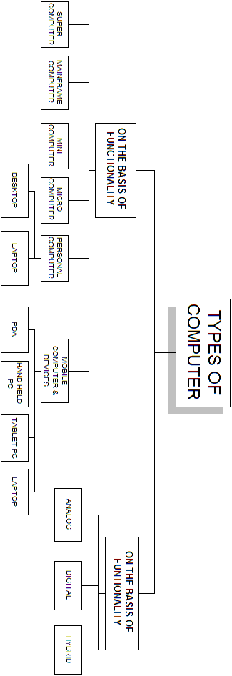

ON THE BASIS OF FUNCTIONALITY:
According to functionality computer can be divided in to three types:
- Analog
- Digital
- Hybrid
ANALOG COMPUTERS:
DEFINITION:
- “An analog (spelled analogue in British English) computer is a form of computer that uses the continuously-changeable aspects of physical fact such as electrical, mechanical, or hydraulic quantities to model the problem being solved.”
- Analog means continuity of associated quantity just like an analog clock measures time by means of the distance traveled by the hand of the clock around a dial.
HISTORY:
Mechanical analog computers were very important in gun fire control in World War II and the Korean War; they were made in significant numbers. In particular, development of transistors made electronic analog computers practical, and before digital computers had developed sufficiently, they were commonly used in science and industry.
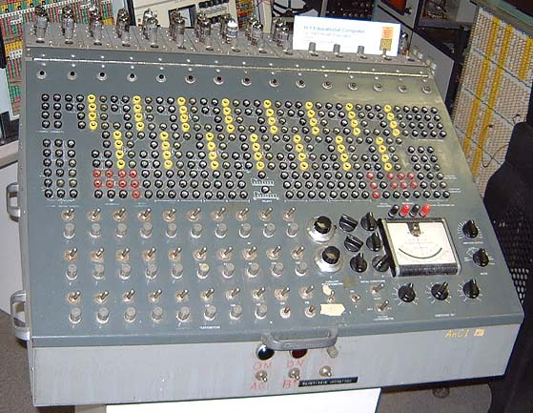

EXAMPLES:
- Thermometer
- Analog clock
- Speedometer
- Tire pressure gauge
ADVANTAGES:
- Analog computer has come to refer to
  - devices and media that represent
  - Store images
  - Sound, motion pictures, etc.
DISADVANTAGES:
- Analog computers can have a very wide range of complexity.
- Slide rules and monographs are the simplest, while naval gun fire control computers and large hybrid digital/analogue computers were among the most complicated.
- Very complicated for containing output for the users some time.
DIGITAL COMPUTERS:
DEFINITION:
- “A computer that performs calculations and logical operations with quantities represented as digits, usually in the binary number system of “0” and “1”.
- “Computer capable of solving problems by processing information expressed in discrete form. By manipulating combinations of binary digits (“0”, “1”), it can perform mathematical calculations, organize and analyze data, control industrial and other processes, and simulate dynamic systems such as global weather patterns. ”
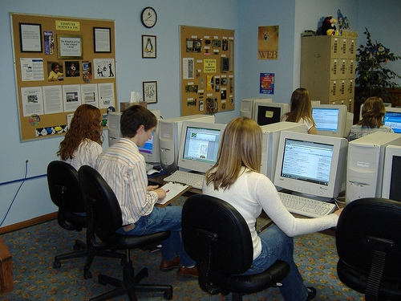

HISTORY:
In 1937 at Bell Labs, George Stibitz invented the first calculator based on binary circuits to perform complex mathematical formulas.
Steinitz’s invention transformed computer science from analog to digital. With the advent of digital technology, scientists could customize a computer's operating functions by developing programming languages.
EXAMPLES:
- IBM PC
- Apple Macintosh
- Calculators
- Digital watches etc
HYBRID COMPUTERS:
DEFINITION:
- “A computer that processes both analog and digital data”.
- “Hybrid computer is a digital computer that accepts analog signals, converts them to digital and processes them in digital form”
A hybrid computer may use or produce analog data or digital data. It accepts a continuously varying input, which is then converted into a set of discrete values for digital processing.
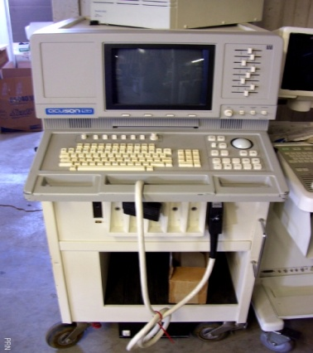
Examples:
- Hybrid computer is the computer used in hospitals to measure the heartbeat of the patient.
- Devices used in petrol pump.
- Hybrid Machines are generally used in scientific applications or in controlling industrial processes.

ON THE BASIS OF SIZE, SPEED AND COST:
We can divide computers on the basis of size cost and speed as:
- Super Computer
- Mainframe Computer
- Mini Computer
- Micro Computer
- Personal Computer
  - Desktop computers
  - Laptop /Note Books
- Mobile Computer & Devices
  - PDA
  - Tablet PC
  - Hand Held Computer
  - Laptop/Note Books
SUPER COMPUTER

Supercomputers are the largest, fastest, most powerful, and most expensive computers made. Like other large systems, supercomputers can be accessed by many individuals at the same time. Supercomputers are used primarily for scientific applications that are mathematically intensive. The first supercomputer was built in the 1960s for the United States Department of Defense.

This computer was designed to be the world's fastest and most powerful computer of that time. The commitment to create the fastest, most powerful computer in the world is still the driving force behind the development of supercomputers. Manufacturers produce relatively few of any one model of supercomputer, and they spend millions of dollars on research and development of new machines.
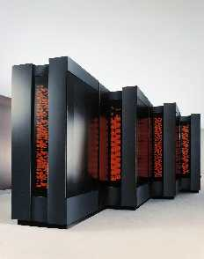
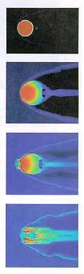

Supercomputers derive much of their speed from the use of multiple processors. Multiprocessing enables the computers to perform tasks simultaneously--either assigning different tasks to each processing unit or dividing a complex task among several processing units.
EXAMPLE:
- Cray-1
- Cray-2
- Control Data Cyber 205
- ETA

FEATURES:

The aerospace, automotive, chemical, electronics and petroleum industries use supercomputers extensively.

Supercomputers are used in weather forecasting and seismic analysis. They are found in many public and private research centers, such as universities and government laboratories.

A supercomputer was used to alert scientists to the impending collision of a comet with Jupiter in 1994, giving them time to prepare to observe and record the event.

The ultra supercomputer will simulate nuclear explosions (eliminating the need to detonate any bombs), model global weather trends, and design power plants.

Supercomputers can perform at up to 128 gigaflops, and use bus widths of 32 or 64 bits. This capability makes supercomputers suitable for processor-intensive applications, such as graphics.
Note:
The speed of modern supercomputers is measured in nanoseconds and gigaflop. A nanosecond is one billionth of a second. A gigaflop is one billion floating-point arithmetic operations per second.

MAINFRAME COMPUTER
Mainframe computers are the most powerful computers. A mainframe computer may contain several microprocessors. A single mainframe computer can be used by hundreds of people at once.
Each user has his own terminal that is connected to the mainframe. Mainframe computers are usually kept in a special cooled, clean computer room. Minicomputers are medium-sized computers which are more powerful than microcomputers but not as powerful as mainframes.
A mainframe computer system is usually composed of several computers in addition to the mainframe, or host processor.
Host Processor:
The host processor is responsible for controlling the other processors, all the peripheral devices, and the mathematics operations.
Front End processor:
A front-end processor is responsible for handling communications to and from all the remote terminals connected to the computer system.
Back end Processor:
Sometimes a back-end processor is used to handle data retrieval operations. Although the host computer could perform all these operations, it can be used more efficiently if relieved of time-consuming chores that do not require processing speed.
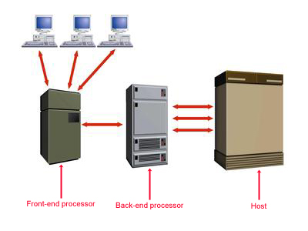

FEATURES:

Mainframe computer systems are powerful enough to support several hundred users simultaneously at remote terminals.

Mainframe Computers are so much faster than people, the users never notice that the computer is handling other tasks.

This capability to process many programs concurrently for multiple users is known as multiprogramming.

The typical mainframe computer occupies much of a large room.

Like supercomputers, mainframes require an environment with closely monitored humidity and temperature.

Mainframe computers are priced between $100,000 and $2,000,000.

EXAMPLE:
- IBM S/390
- Amdahl 580
- Control Data Cyber 176

MINI COMPUTER
The "age of the mini" started in the late 1960s. The creation of integrated circuits suitable for computers enabled designers to shrink the size of the computer. Minicomputers are frequently referred to as mid-range computers.
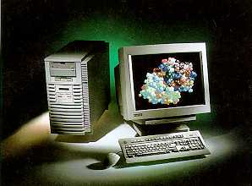

Before Digital Equipment Corporation (DEC) released the first DEC PDP-8 minicomputer in 1968, most medium-sized organizations were priced out of the computer market because they couldn't afford mainframe computers.

FEACTURES:

Like mainframes, most minicomputers are multiuser systems.

Many of today's minicomputers can accommodate as many as 200 users working from individual terminals.

Mini computers are a little slower than mainframe.

Like mainframes, minicomputers can accommodate remote users, but not as many.

Minicomputers' input, output, and storage devices look like those on mainframes.

Minicomputers have slightly less storage, and the printers are slightly slower.

EXAMPLE:
- IBM AS/400
- IBM SYSTEM 360
- HP 3000
- PRIME 9755
MICROCOMPUTER
When you are working on a multiuser computer, such as a mainframe or minicomputer, you can control the input and see the output on the display, but you control nothing else.
A single-user computer gives you control over all the phases of computer processing: input, processing, output, and storage. You can select the programs you want to use, and you don't have to compete with other users to gain access to the system. A single-user system is designed to meet the computing needs of an individual.
Single-user computers fall into two categories:
- Workstations
- Microcomputers.

WORKSTATION:
A workstation is a powerful desktop computer designed to meet the computing needs of engineers, architects, and other professionals who need detailed graphics displays. The workstation has sometimes been called a "super micro." The workstation looks very much like a desktop microcomputer, but the chips inside make the difference
For example, workstations are commonly used for computer-aided design (CAD), in which industrial designers create pictures of technical parts or assemblies. To process these complex and detailed diagrams, the computer needs great processing power and much storage.
FEATURES:

Workstations are small, powerful systems designed to drive networks of less powerful microcomputers and to create high-quality graphics.

Workstations typically cost $5,000 to $20,000.

Major competitors in this market include DEC, Hewlett-Packard, Sun, and Silicon Graphics, Inc.

MICROCOMPUTERS:
It is difficult to overstate the impact of the microcomputer on the computer industry. In 1975, the microcomputer did not exist. In 1995, sales exceeded $116 billion. Microcomputers are the fastest growing segment of the computer industry.
The microcomputer segment of the industry is complex; there are different types of microcomputer platforms with varying capabilities. The most common type of microcomputer is a desktop computer, which is a non portable personal computer that fits on top of a desk. (will describe below).
Microcomputers are the smallest and cheapest of these and are used at home, in schools and in some businesses. Mainframe computers are the most powerful computers
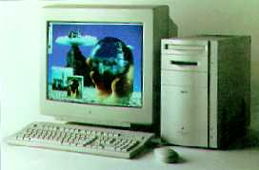

This table makes some comparisons between the different types of computer:
Comparison | Microcomputer | Minicomputer | Mainframe
Where Used | Home, small business, on a network in a larger business. | Medium sized business. e.g. supermarket, traffic control system. | Large businesses, universities.
Number of Users | 1 | 1 - 20 | Hundreds
Cost | 30,000 – 200,000 Rs | 25,000-100,00 Rs | Rs 2,000,000+

PERSONAL COMPUTER
DEFINATION:

“A small computer, intended for use by an individual. A personal computer will usually fit on a desk.”

A computer designed for use by a single user. Although other Microcomputers preceded it, the IBM PC was the first to use the name specifically. As a result, the term PC now applies to an IBM-compatible computer as contrasted to the Apple Macintosh, these being the two standards that emerged from an abundance of competitors in the early 1980s.

PC further divided in to two types:

Desktop Computer

Laptop/ Note book Computer
DESKTOP COMPUTER:
DEFINATION:
“A computer designed for desktop use; usually comprises, at a minimum, a central processing unit (CPU), a monitor, and a keyboard as separate units, connected by special cables. Most such computers now also include a Pointing Device.

A computer that could fit on a desk was considered remarkably small. Desktop computers come in a variety of types ranging from large vertical tower cases to small form factor models that can be tucked behind an LCD monitor.

"Desktop" can also indicate a horizontally-oriented computer case usually intended to have the display screen placed on top to save space on the desktop. Most modern desktop computers have separate screens and keyboards.
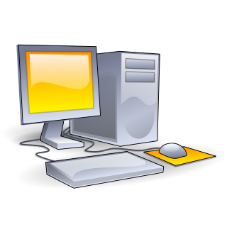
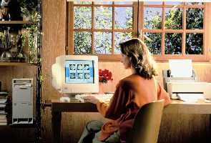

LAPTOP /NOTE BOOK COMPUTER:
DEFINATION:

“A laptop is a personal computer designed for mobile use, small and light enough to sit on a person's lap while in use.”

“A portable computer typically weighing less than 6 pounds (3 kilograms) that has a flat-panel display and miniature hard disk drives, and is powered by rechargeable batteries.”

Laptops are capable of many of the same tasks that desktop computers perform, although they are typically less powerful. Laptops contain components that are similar to those in their desktop counterparts and perform the same functions but are miniaturized and optimized for mobile use and efficient power consumption. Laptops usually have LCD displays.

Laptops generally cost around twice as much as a desktop machine of similar specification. Performance is always lower than that of a comparable desktop because of the compromises necessary to keep weight and power consumption low.
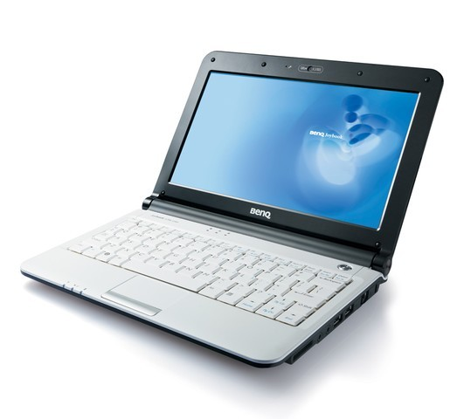
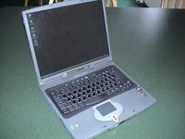

MOBILE COMPUTERS / DEVICES
All devices which can carry in hand and portable, is said to be mobile devices and computers.
These Devices are categorized in:
  - PDA
  - Tablet PC
  - Hand Held Computer
  - Laptop/Note Books
PDA
DEFINITION:
PDA stands for “Personal Digital Assistant”. A small, handheld system combining in one device multiple computing, Internet, networking, and fax/telephone features”A PDA contain following features:
- Keep phone directories
- Calendars and provide calculator capabilities
- Schedule appointments

Retrieve frequently used phone numbers

Jot down notes.

Most PDAs are designed to accept written input by a pen; the PDA decodes what you write.
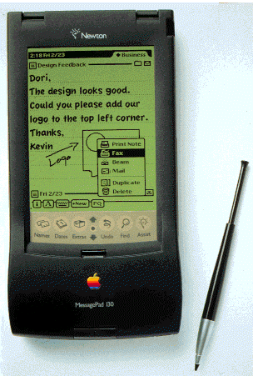

TABLET PC
DEFINATION:

“A tablet PC is a wireless personal computer (PC) that allows a user to take notes using natural handwriting with a stylus or digital pen on a touch screen.”

A tablet PC is similar in size and thickness to a yellow paper notepad and is intended to function as the user's primary personal computer as well as a note-taking device.

Tablet PCs generally have two formats, a convertible model with an integrated keyboard and display that rotates 180 degrees and can be folded down over the keyboard or a slate style, with a removable keyboard.
The user's handwritten notes, which can be edited and revised, can also be indexed and searched or shared via e-mail or cell phone.

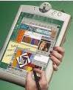
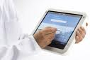

HAND HELD COMPUTER
DEFINITION
- “Very small, lightweight device (such as the Palm Pilot) which provides functionality approaching that of a laptop computer. “
Features of modern handhelds include calendar and diary organizing, word processing, data management, remote access to firm's network, internet access, wireless access, messaging, etc
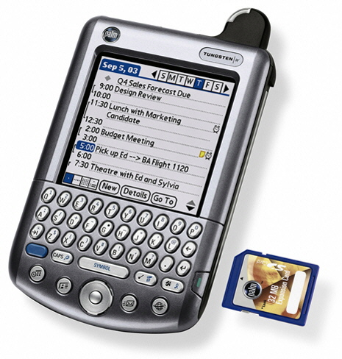

LAPTOP/NOTE BOOKS COMPUTER
DEFINATION:

“A laptop is a personal computer designed for mobile use, small and light enough to sit on a person's lap while in use.”

“A portable computer typically weighing less than 6 pounds (3 kilograms) that has a flat-panel display and miniature hard disk drives, and is powered by rechargeable batteries.”

Laptops are capable of many of the same tasks that desktop computers perform, although they are typically less powerful. Laptops contain components that are similar to those in their desktop counterparts and perform the same functions but are miniaturized and optimized for mobile use and efficient power consumption. Laptops usually have LCD displays.

Laptops generally cost around twice as much as a desktop machine of similar specification. Performance is always lower than that of a comparable desktop because of the compromises necessary to keep weight and power consumption low.

